**Download ssl certificate and install (STRUST)**

<https://y0160-iflmap.hcisbp.eu1.hana.ondemand.com/cxf/hcm2bizx/SFSFUserUpsertRequestConfirmation>

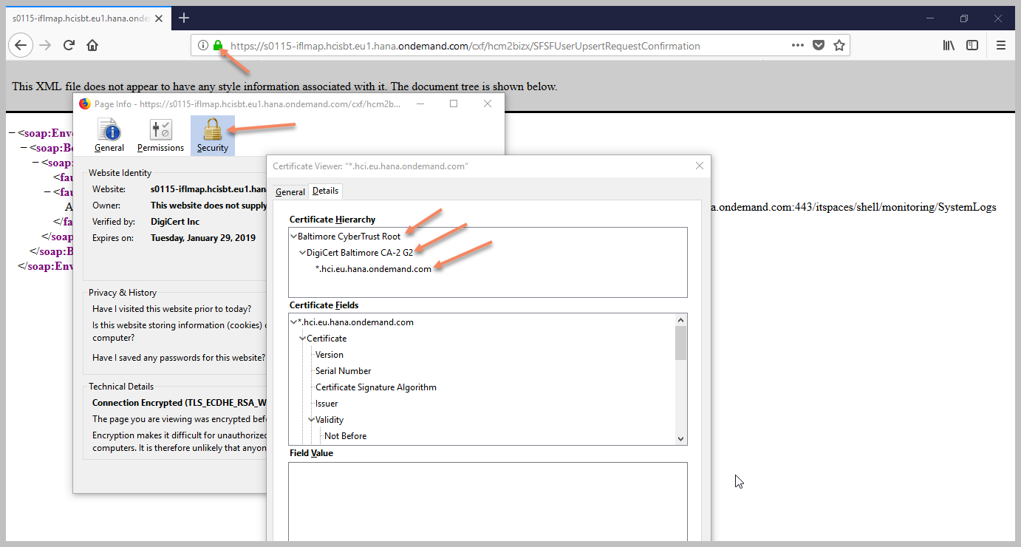

You need to put the certificates into the STRUST by default it puts the certificates in System PSE but you will also need to check if the SSL Client WSSE Web Service folder contains the certificates.

You should install certificate SSL client Standard, SSL client anonymous (for basic authentication; user ID/PW)

SOAMANAGER configuration

1. Go to the *SOA Management* (SOAMANAGER) transaction in your SAP ERP HCM system and choose *Web Service Configuration*.
2. Search for the CO_SFI_SE_SFSFUSER_UPSERT_RC consumer proxy and select the corresponding entry in the search result.

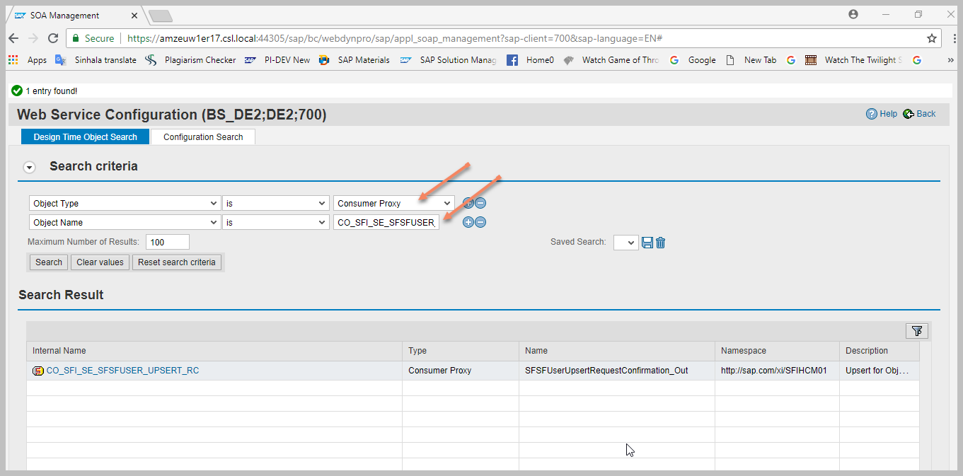

1. Choose *Create 🡪 WSDL Based Configuration* and create a new logical port.

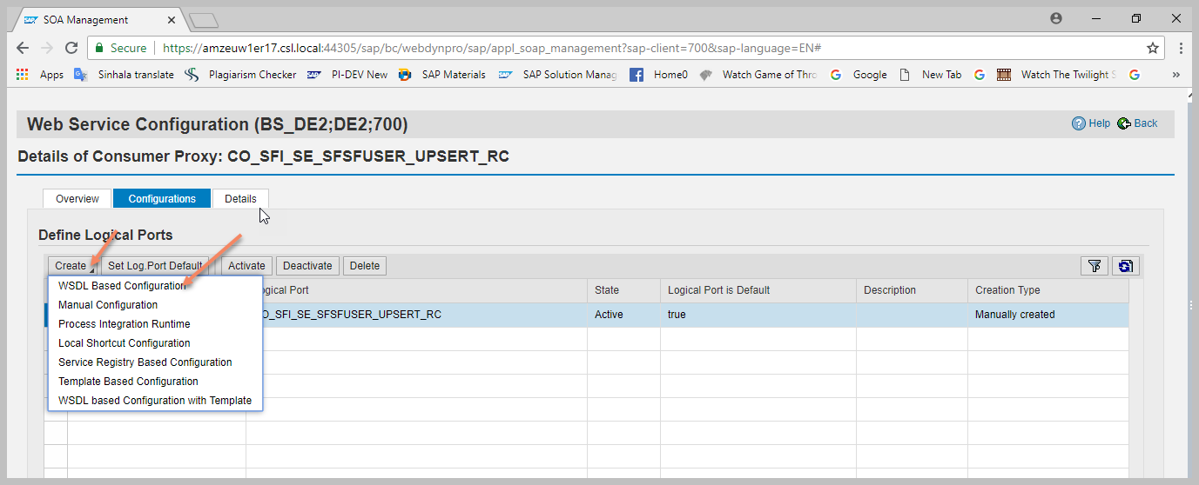

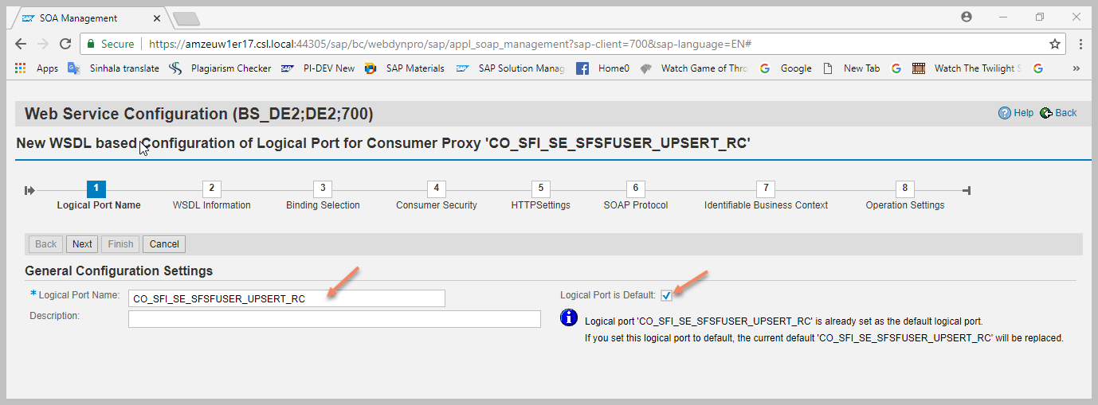

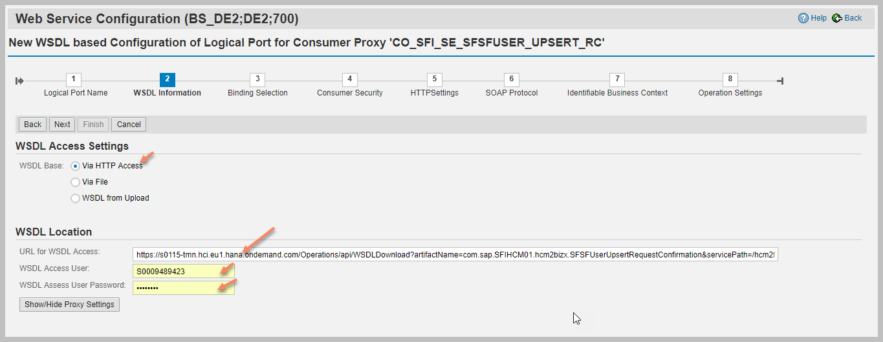

WSDL URL (Upsert)

<https://y0160-tmn.hci.eu1.hana.ondemand.com/Operations/api/WSDLDownload?artifactName=com.sap.SFIHCM01.hcm2bizx.SFSFUserUpsertRequestConfirmation&servicePath=/hcm2bizx/SFSFUserUpsertRequestConfirmation&domainName=hcisbp.eu1.hana.ondemand.com&abapConsumer=true&includePolicies=true>

This user (S0009489423) should be authorized to access HCI.

Note: S0009489423 is Sisila’s S-user ID use for testing

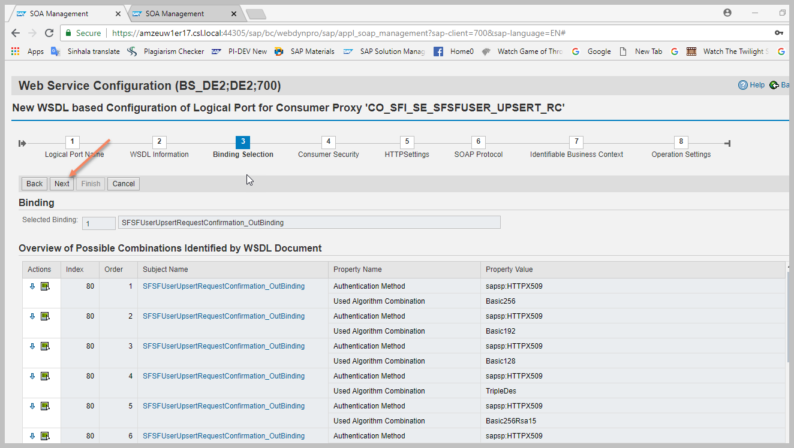

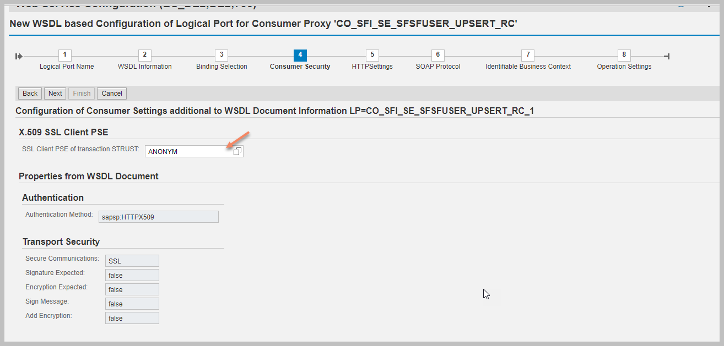

1. Transport Settings:
   1. URL access path = /cxf/hcm2bizx/SFSFUserUpsertRequestConfirmation_TE2
   2. URL protocol information = HTTPS
   3. Computer name of access URL = [s0115-iflmap.hcisbt.eu1.hana.ondemand.com](https://s0115-iflmap.hcisbt.eu1.hana.ondemand.com)
   4. Port number of access URL = 443
   5. Logon language = Language of User Context
   6. ~~Name of proxy host = Select “Proxy~~”
   7. ~~Port number of proxy host = 8080~~
   8. Transport binding type = Select SOAP 1.1.
   9. Make local call = Select No Call in Local System.
   10. ~~WSDL style = Select Document Style~~.
   11. Optimized XML transfer= Select None.
   12. Compress HTTP message = Select Inactive.
   13. Compress response = Select True.

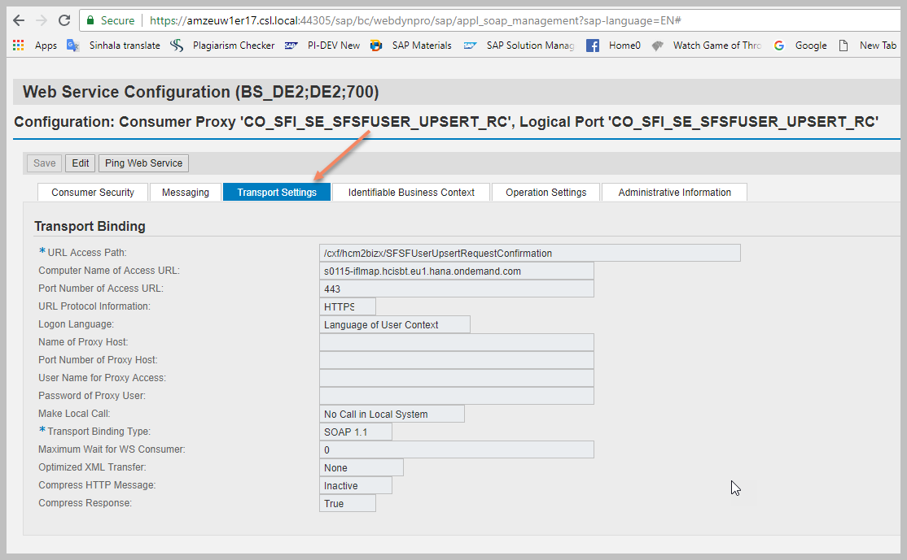

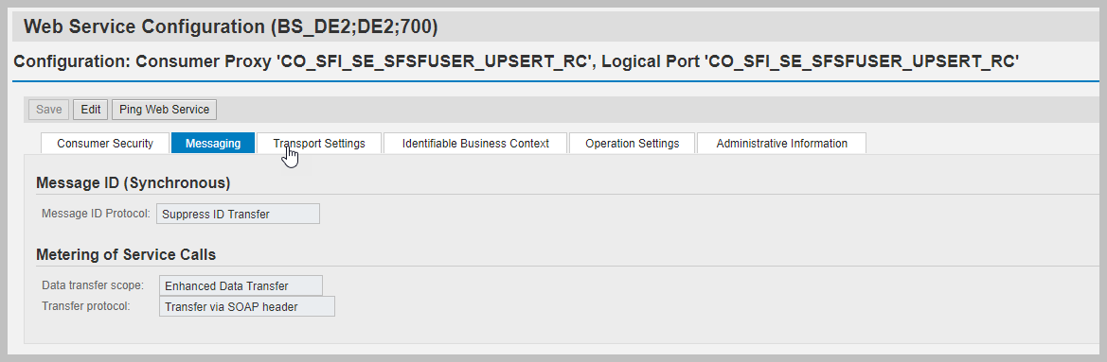

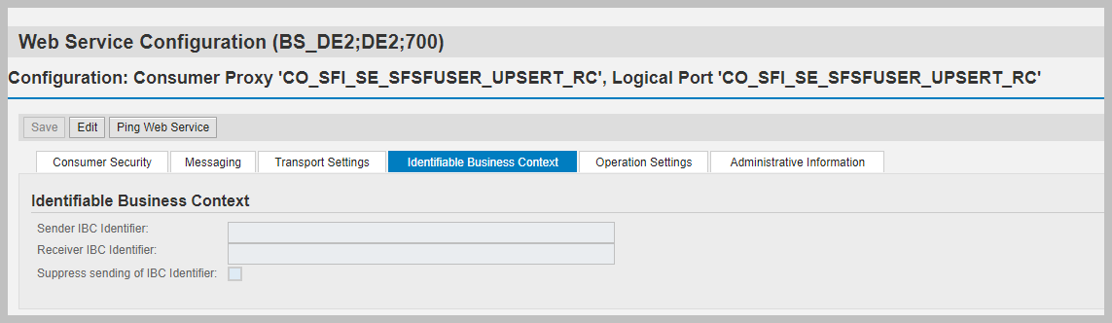

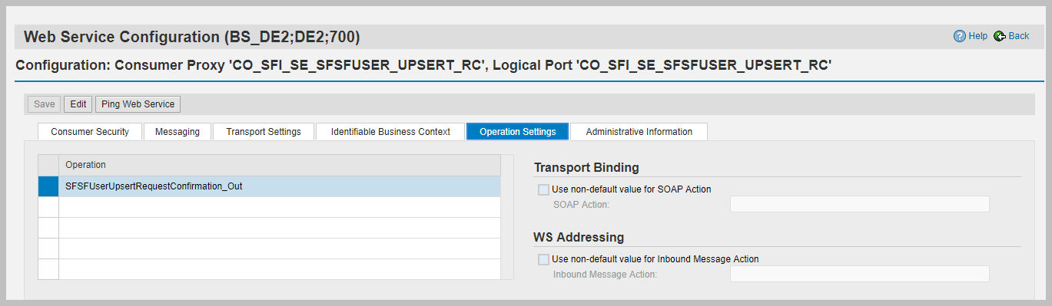

Web service ping

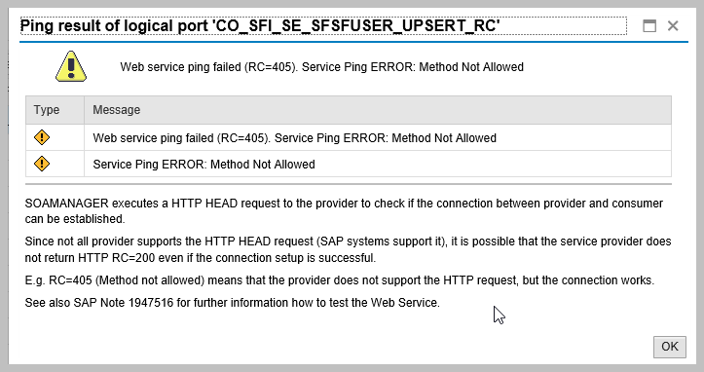

**Create Manual configuration for login and logout**

For this SFSFSessionHandlingLogoutQueryResult

* For Step #2: CO_SFI_SE_SESS_HNDL_LOGOUT_QR
* For Step #5a: /cxf/hcm2bizx/SFSFSessionHandlingLogoutQueryResult_TE2

WSDL:  
<https://y0160-tmn.hci.eu1.hana.ondemand.com/Operations/api/WSDLDownload?artifactName=com.sap.SFIHCM01.hcm2bizx.SFSFSessionHandlingLogoutQueryResult&servicePath=/hcm2bizx/SFSFSessionHandlingLogoutQueryResult&domainName=hcisbp.eu1.hana.ondemand.com&abapConsumer=true&includePolicies=true>

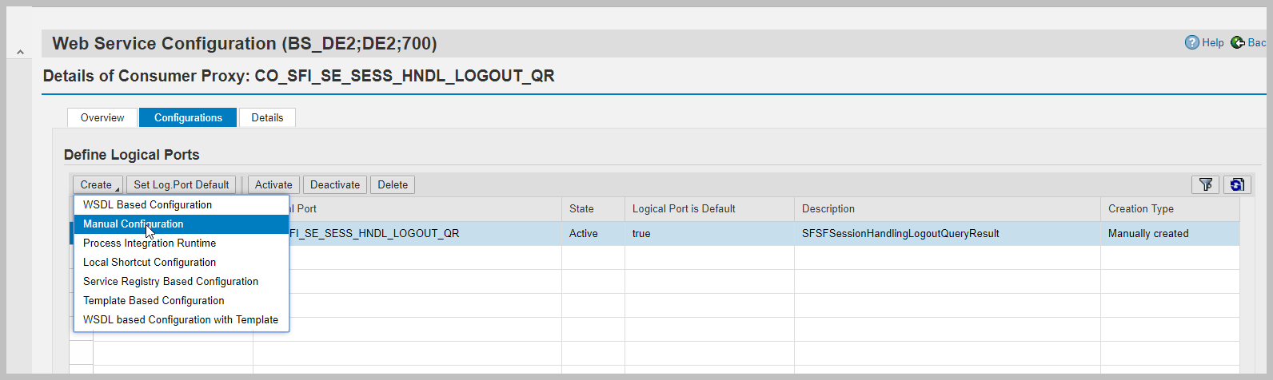

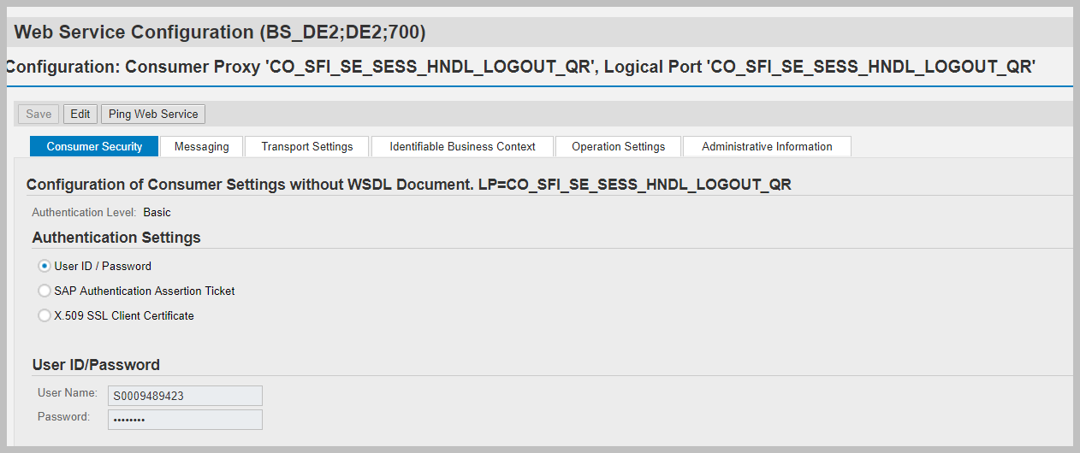

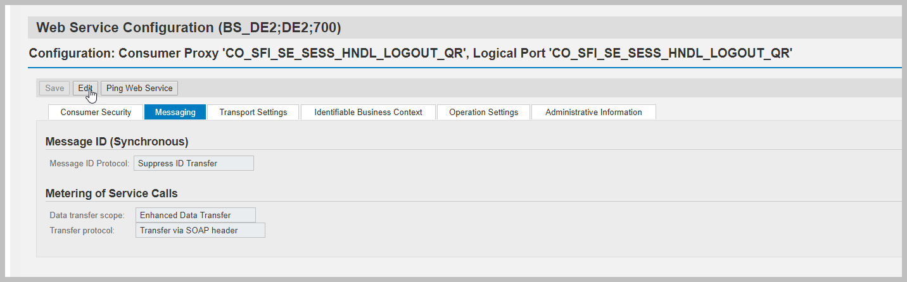

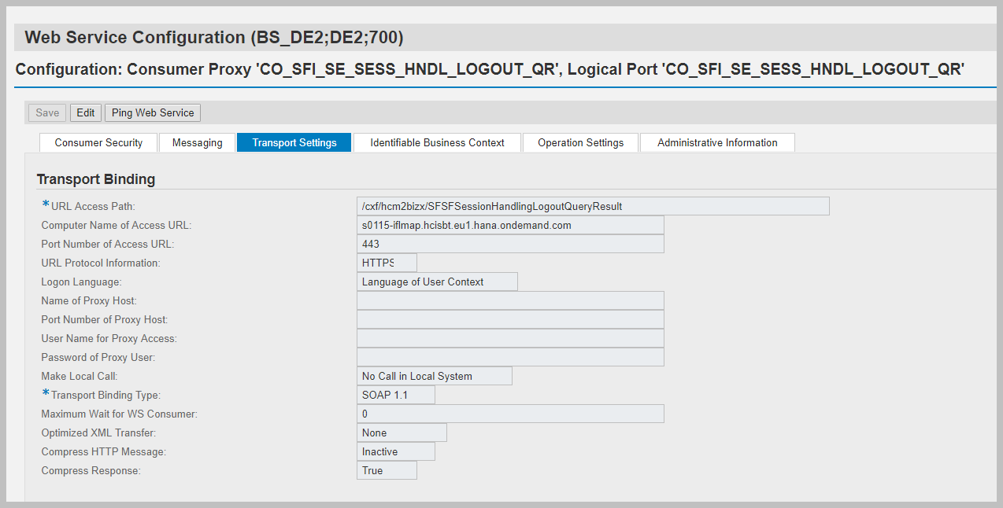

Follow the same steps for login

For this SFSFSessionHandlingLoginQueryResult

* For Step #2: CO_SFI_SE_SESS_HNDL_LOGIN_QR
* For Step #5a: /cxf/hcm2bizx/SFSFSessionHandlingLoginQueryResult_TE2

Wsdl:

<https://y0160-tmn.hci.eu1.hana.ondemand.com/Operations/api/WSDLDownload?artifactName=com.sap.SFIHCM01.hcm2bizx.SFSFSessionHandlingLoginQueryResult&servicePath=/hcm2bizx/SFSFSessionHandlingLoginQueryResult&domainName=hcisbp.eu1.hana.ondemand.com&abapConsumer=true&includePolicies=true>

